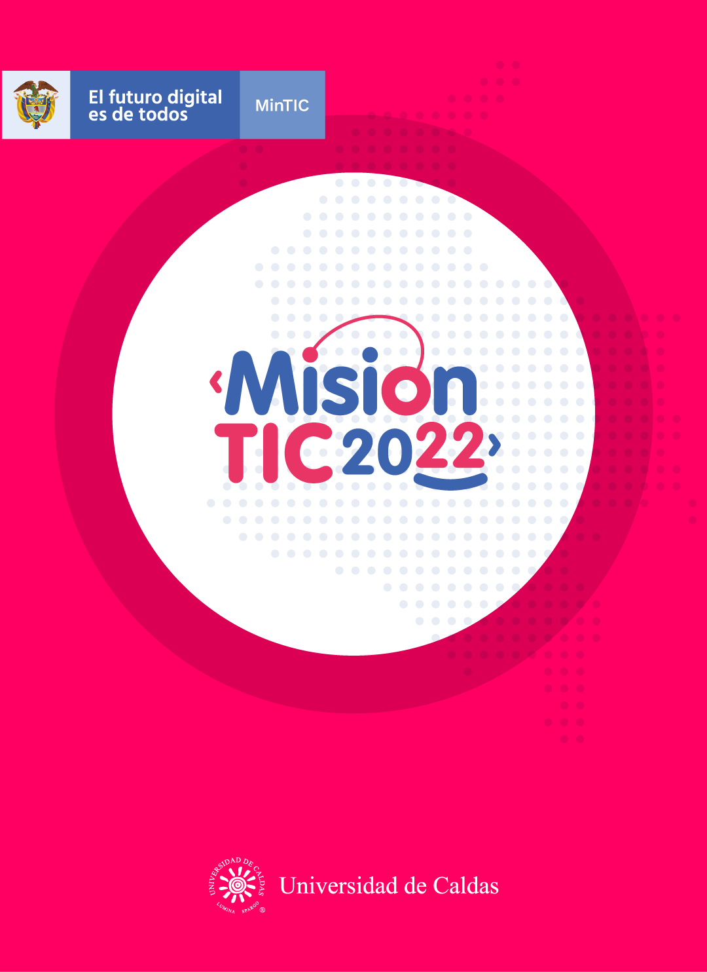

**RELATIONAL DATABASE AND SQL**

**Relational Database and SQL**

**Worksheet 2.1**

**Vocabulary:** Write the translation or a synonym for each word.

* Integer:Whole number or numero entero
* String:A chain of characters/cadena de texto o caracteres-sequence of symbols-secuencia de simbolos
* Set: establish/Establecer/configure-configurar/estimate a price-estimar un price- a group of things or number of things-conjunto
* Tables: Tabla/mesa(desk)/Data estructure-estructura de datos/chart-a set of rows and columns-conjunto de filas y columnas
* Row: Filas-Horizontal line/queue
* Column: Columnas-Vertical line /Article of comment or opinion-articulo de comentario o opinion
* Label: Tag/ Etiqueta,sello ,rotulo /Brade-trade mark:Marca
* Management: administrate/administration--Gestion,administracion
* Query:Make a request-a question-a ask /Consulta,peticion,preguntar

**Worksheet 2.2**

**Match the word in the left column with its meaning in the right column.**

|  |  |  |
| --- | --- | --- |
| **A WORD** |  | **B MEANING OF THE WORD** |
| 1. Integer | **i** | A. A number of things of the same kind that belong or are used together |
| 2. Strings | **f** | B. It is a data structure used to organize information. |
| 3. Set | **a** | C. It is a request for information. |
| 4. Table | **b** | D. The process of controlling things or people |
| 5. Rows | **g** | E. They run vertically, up and down. |
| 6. Columns | **e** | F. It is a character value represented in quotes. |
| 7. Label | **h** | G. They run horizontally, from left to right |
| 8. Management | **d** | H. An item used to identify something |
| 9. Query | **c** | I. It is a numeric value. |

**Worksheet 2.3**

**Watch the video “text to self-connections” and answer the following questions.**

* What is text to self-connection?

Connect the text that you read with your own life experiences

* What are three questions you can ask yourself?

1. Has this ever happened to me?
2. Do I know someone like this character?
3. Have I ever experience a place like this?

* Now Choose a story that you can use the strategy (text to self-connection) with and complete the following sentences.

1. I had a strong connection to this because: i remind when i was with a girl but the life is a great surprice and now we aren't together

2. This character reminds me of my mother because is a hardworker person

3. The setting reminds me of a time when was in the school and leave with the guys to play or doing crazy things today we are far and distant

**Worksheet 2.4**

**Read the text and highlight the words that are new for you.**

**What is a Database?**

A database is a **set** of data stored in a computer. This data is usually structured in a way that makes the data easy to access.

**What is a Relational Database?**

A relational database is a type of database. It uses a structure that allows us to identify and access data in relation to another piece of data in the database. Often, data in a relational database is organized into tables.

**Tables: Rows and Columns**

**Tables** can have hundreds, thousands, sometimes even millions of **rows** of data. These rows are often called *records*.

Tables can also have many **columns** of data. Columns are **labeled** with a descriptive name (say, *age, name or country,* for example) and have a specific data type.

The name and country columns store **string** data types, whereas age stores **integer** data types. The set of columns and data types make up the *schema* of this table.

**What is a Relational Database Management System (RDBMS)?**

A relational database **management** system (RDBMS) is a program that allows you to create, update, and administer a relational database. Most relational database management systems use the SQL language to access the database.

**What is SQL?**

SQL (Structured **Query** Language) is a programming language used to communicate with data stored in a relational database management system. SQL syntax is similar to the English language, which makes it relatively easy to write, read, and interpret.

Many RDBMSs use SQL (and variations of SQL) to access the data in tables. For example, SQLite is a relational database management system. SQLite contains a minimal set of SQL commands (which are the same across all RDBMSs). Other RDBMSs may use other variants.

(Note: SQL is often pronounced in one of two ways. You can pronounce it by speaking each letter individually like “S-Q-L”, or pronounce it using the word “sequel”.)

**Worksheet 2.5**

**You will work in groups. Read again the text. After that, create a database compiling personal information about the members of your group.**

Example:-

|  |  |  |  |  |  |  |
| --- | --- | --- | --- | --- | --- | --- |
| Name | Age | City of origin | Profession | ____________ | _______ | ___________ |
|  |  |  |  |  |  |  |
|  |  |  |  |  |  |  |
|  |  |  |  |  |  |  |
|  |  |  |  |  |  |  |
|  |  |  |  |  |  |  |

**Worksheet 2.5**

**Answer the following questions!**

Entiendo que es relational database.

Yes **😃** Maybe **😐** No **😟**

Entiendo cómo puedo crear relational database.

Yes **😃** Maybe **😐** No **😟**

La estrategia Text-self me ayuda a entender un texto mejor.

Yes **😃** Maybe **😐** No **😟**